Do you agree or disagree?  Use if you agree and if you disagree  - Television feeds you false information  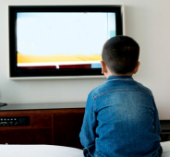  - Watching television leaves nothing to our imagination.  - You become lazy and fat.  - TV commercials are producing stress.  - Watching actions and horrors can increase your aggression because of numerous scenes of violence.  - It interferes with my studies  - Television wastes your time. If you watch 6 hours of television every day, then you’re spending 2,190 hours in a year doing nothing. So, if we assume the life expectancy to be 70 years, 153,300 hours or 11 years of your life are wasted in watching television |  |  | Do you agree or disagree?  Use if you agree and if you disagree  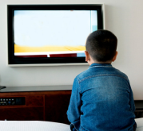  - Television feeds you false information  - Watching television leaves nothing to our imagination.  - You become lazy and fat.  - TV commercials are producing stress.  - Watching actions and horrors can increase your aggression because of numerous scenes of violence.  - It interferes with my studies  - Television wastes your time. If you watch 6 hours of television every day, then you’re spending 2,190 hours in a year doing nothing. So, if we assume the life expectancy to be 70 years, 153,300 hours or 11 years of your life are wasted in watching television
Numerous – многочисленный. To waste time- тратить время  Commercials – реклама. To interfere – служить препятствием |  |  | Numerous – многочисленный. To waste time- тратить время  Commercials – реклама. To interfere – служить препятствием
Do you agree or disagree?  Use if you agree and if you disagree  - Television feeds you false information  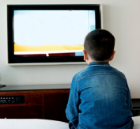  - Watching television leaves nothing to our imagination.  - You become lazy and fat.  - TV commercials are producing stress.  - Watching actions and horrors can increase your aggression because of numerous scenes of violence.  - It interferes with my studies  - Television wastes your time. If you watch 6 hours of television every day, then you’re spending 2,190 hours in a year doing nothing. So, if we assume the life expectancy to be 70 years, 153,300 hours or 11 years of your life are wasted in watching television |  |  | Do you agree or disagree?  Use if you agree and if you disagree  - Television feeds you false information  - Watching television leaves nothing to our imagination.  - You become lazy and fat.  - TV commercials are producing stress.  - Watching actions and horrors can increase your aggression because of numerous scenes of violence.  - It interferes with my studies  - Television wastes your time. If you watch 6 hours of television every day, then you’re spending 2,190 hours in a year doing nothing. So, if we assume the life expectancy to be 70 years, 153,300 hours or 11 years of your life are wasted in watching television
Numerous – многочисленный. To waste time- тратить время  Commercials – реклама. To interfere – служить препятствием |  |  | Numerous – многочисленный. To waste time- тратить время  Commercials – реклама. To interfere – служить препятствием

